1. Create different schemas for WM, MDA and import_export
   1. In the properties tab, give all details like hostname, sid, port etc…
   2. Username is the schema name, so create a different schema just change the username * password in the properties and save it as new schema, it should be like :
   3. WM Schema username - BIGL2016WMDEV
   4. MDA Schema username - BIGL2016MDADEV
   5. Import_export schema username – import_export/impexpus3r
2. Table backup of following table from both the schemas:

**MDA Schema:**

select * from app_instance;

select * from xsolution;

select * from saml_metadata;

select * from router;

select * from xsolution_app;

select * from listener;

select * from cl_protocol_ftp;

select * from cl_protocol_tcp;

select * from whse_parameters;

select * from ftp_listener;

select * from APPLICATION_CONFIGURATION;

select * from ucl_user where user_name in ('WMADMIN','LMADMIN','MHEADMIN','system','rdaily','MAADMIN');

select * from ucl_user where user_name in ('wmsadmin',' rdaily',' GMTRWM2016DEV');

**WM Schema:**

select * from cl_machine;

select * from router;

select * from APPLICATION_CONFIGURATION;

select * from APPLICATION_CONFIGURATION where key in ('vbroker.agent.port','vbroker.agent.addr','label.vbroker.agent.port','label.vbroker.agent.addr',

'ORBInitRef.NameService','ehcache.replication.peer.list','mda.external.hostname','dif.corba.host','dif.corba.port','smtp.hostname');

select * from APPLICATION_CONFIGURATION

where key in ('vbroker.agent.port','vbroker.agent.addr','label.vbroker.agent.port','label.vbroker.agent.addr','ORBInitRef.NameService','ehcache.replication.peer.list','mda.external.hostname');

select * from user_profile where login_user_id in ('WMADMIN','LMADMIN','MHEADMIN','system','rdaily','MAADMIN');

1. Drop mail for stopping servers to respective DL
2. Upload the dump file to the db host sftp://taurus.us.manh.com import_export impexpus3r
3. Next, check for user sessions in WM & MDA

set serveroutput on;

exec manh_show_sessions;

1. Kill any sql developer sessions using the below query:

First arg is sid, second is next in the session out result (First two param from output of sessions)

exec manh_kill_session ('3793','1615');

exec manh_kill_session ('3795','4317');

1. Disconnect from WM & MDA schemas
2. Connect to import_export schema
3. Copy paste the script & execute it from import_export schema

set echo on serveroutput on;

begin

manh_import(

p_project_code => 'GMTR',

p_email_id => 'snanjannavar@manh.com',

p_dmp_dir => 'DMP',

p_dmp_file => 'expdp_wm51018d_20180105.dmp',

p_source_schemas => 'WM_MASC_WM1,WM_MASC_LMDA1',

p_target_schemas => ' GMTR2016WMSDN,GMTR2016MDASDN '

);

end;

/

Source schema names can be obtained from log file which comes along with dump files

Target schemas are your MDA & WM schema

**In 2011 clients – MDA/MSF is called as SCPP schema**

1. Check status of your job

select * from MANH_DPUMP_JOBS;

select * from MANH_DPUMP_JOBS where job_no = ‘4883’;

1. Wait for the mail from Oracle with message: DB Import completed with * number of errors
2. Download the impdmp*.log file and check if any specific error is present in that, else proceed.

**LICENSE GENERATION:**

1. Open IE (not edge)
2. Go to url: <http://helios-t:10000/license/>
3. Login as Anonymous
4. Under -> Generate License for 2010 and Higher Releases, click on Internal License
5. In Licensee Name give Client Code, Env, Yr. E.g. GMTR2016DEV, VITAQA2015
6. Scroll and click on Add All
7. Go to end of page, enter your email id in box
8. Then Click on Save, Click on confirm on Next page.
9. You’ll receive the license in mailbox within few minutes.
10. Done

**POST IMPORT STEPS:**

1. Update the app_instance table with the correct hostname and port number.

Example below:

Previously:

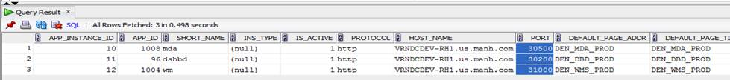

After update :

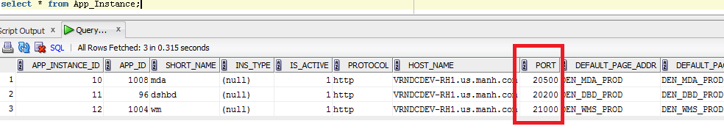

1. Similarly we updated the name, description, host name and port number in xsolution table.

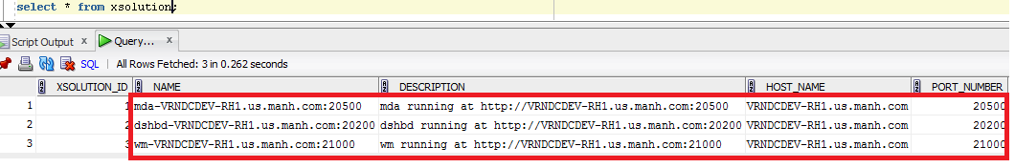

1. Make sure that synonyms are accessible

Run the query “select * from ucl_user;” from WM schema. If synonyms are not accessible, create a DBA request and ask them to correct synonyms.

1. Select * from saml_metadata (if exists)

delete from saml_metadata;

1. Update APPLICATION_CONFIGURATION if exists
2. Validate DB sequences: Run the sequence update script for MDA and WM in DB.



1. Compile schemas – run in both mda & wm instances

*exec dbms_utility.compile_schema('*ADDRWMLM13DEV*');*

1. Commit;

**IMPORTING LICENSE:(First try with this)**

**From mmc**

**IMPORTING LICENSE:**

1. Copy paste the license file to the app-box.
2. cd to $SCPP_HOME/profile-root/tools-*server/scpp
3. run “ant import-license” command
4. enter the path and name of .lic file pasted in app-box
5. Done

**BRING THE SERVERS UP, then**

**GATHERSTATS:**

exec dbms_stats.gather_schema_stats(ownname=>'BIGL2016MDADEV', estimate_percent=>100, cascade=>true, options=>'gather', method_opt=>'for all indexed columns size auto', no_invalidate=>false);

**ACCOUNT LOCKED IN UI:**

Update last_login_dttm & number_of_invalid_logins field in ucl_user table for that user and retry logging.